# **Introduction to JavaScriptgr**

# **Instructor: Syda Fatima**

# JavaScript

* JavaScript is a client-side scripting language
* JavaScript was designed to add interactivity to HTML pages
* JavaScript is used in millions of Web pages to improve the design, validate forms, detect browsers, create cookies, and much more
* JavaScript is an interpreted language (means that scripts execute without preliminary compilation)
* JavaScript is usually embedded directly into HTML pages
* Everyone can use JavaScript without purchasing a license
* JavaScript is the most popular scripting language on the internet and works in all major browsers, such as Internet Explorer, Mozilla, Firefox, Netscape, Opera.

# JavaScript: Common uses

* JavaScript gives HTML designers a programming tool
* JavaScript can react to events
* JavaScript can read and write HTML elements
* JavaScript can be used to validate data
* JavaScript can be used to detect the visitor's browser
* JavaScript can be used to create cookies

# Embedding JavaScript in HTML

* There are two methods to embed JavaScript in to HTML code
  + Internal Script: directly written in HTML code
  + External Script: written in separate file
* <script> tag is used to tell the browser that a script follows

# Internal script

* The <SCRIPT> tag is used to embed JavaScript code in HTML documents

<SCRIPT LANGUAGE="JavaScript">

[*JavaScript Statements...*]

</SCRIPT>

* JavaScript can be placed anywhere between <HTML> and </HTML> tags
* two possibilities are the <HEAD>…</HEAD> portion and the <BODY>…</BODY> portion

<HTML>

<HEAD><TITLE>Using Multiple scripts</TITLE>

<SCRIPT LANGUAGE="JavaScript">

[JavaScript statements...]

</SCRIPT>

<SCRIPT LANGUAGE="JavaScript">

[JavaScript statements...]

</SCRIPT>

</HEAD>

<BODY>

<H1>This is another script</H1>

<SCRIPT LANGUAGE="JavaScript">

[JavaScript statements...]

</SCRIPT>

</BODY></HTML>

# External script

* We place script in a separate file and include this in HTML code
* SRC attribute of the <SCRIPT> is used to include the external JavaScript file in HTML
  + <script src="myscripts.js"> </script>
* Are useful when you have lengthy scripts
* Improve the readability

# JavaScript Convention

* Using the Semicolon

document.write("Hello"); alert("Good bye")

document.write("Hello")

alert("Good bye")

document.write("Hello");

alert("Good bye");

* Case Sensitivity
* Comments:
  + single line //
  + Multiple lines /* */
* Using Quotes
  + document.write(“<font color=“red”>Hello World</font>”)
  + document.write(“<font color=‘red’>Hello World</font>”)

# Writing JavaScript

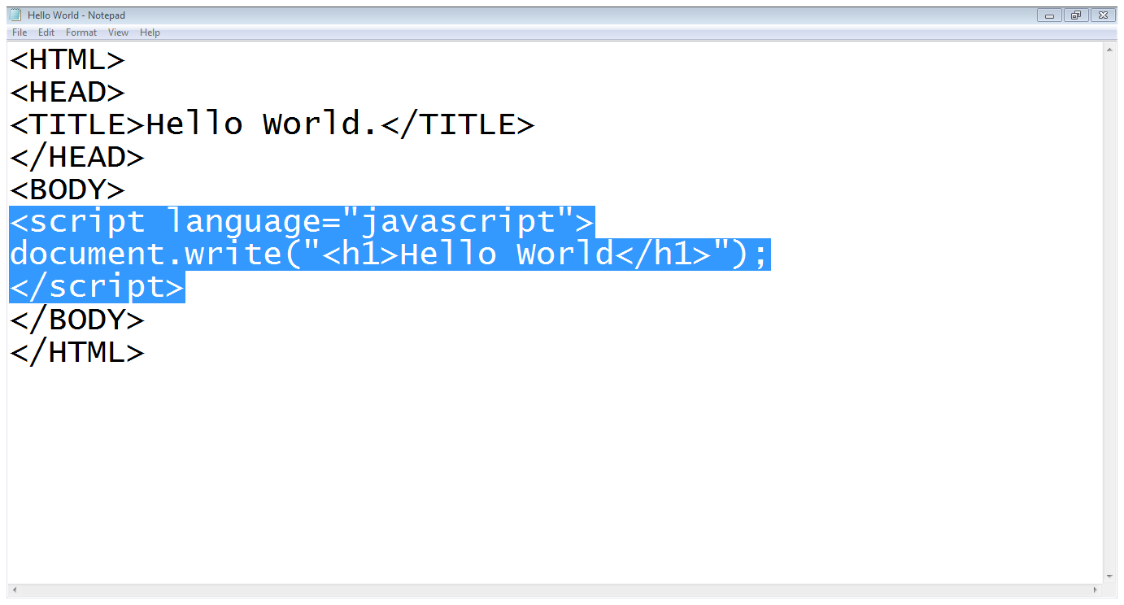

# Variables in JavaScript

* Variable is the name of a memory location which holds the data of a certain type (data types)
* There are four common data types in JavaScript
  + numbers, strings, Boolean, null values
* JavaScript is a loosely typed language
* The word “var” is used to declare a variable
  + var LastName = “Smith”
  + var AccountNumber = 1111
* Variable Naming
  + First character cannot be a digit
  + Other characters may be digits, letters or underscore
  + Reserved words cannot be useds
  + Case sensitive
* Variable Initialization
  + var *variableName* = *initialValue*
  + var variableName1 = initialValue1, variableName2 = initialValue2, …

# JavaScript Operators

* An operator is simply a symbol that tells the compiler (or interpreter) to perform a certain action
* Assignment Operator: =
* Arithmetic Operators: +, - , *, /, %, ++, --
* Logical Operators: &&, ||, !
* Comparison Operators: = =, = = =,! =, != =, <, >, <=, >=

# Input output in JavaScript

* write(); is used to write on browser
  + document.write(“hello world”)
  + document.write(a)
* prompt(); is used to take input from users
  + var num = prompt(“Please Enter a Number”, 0)

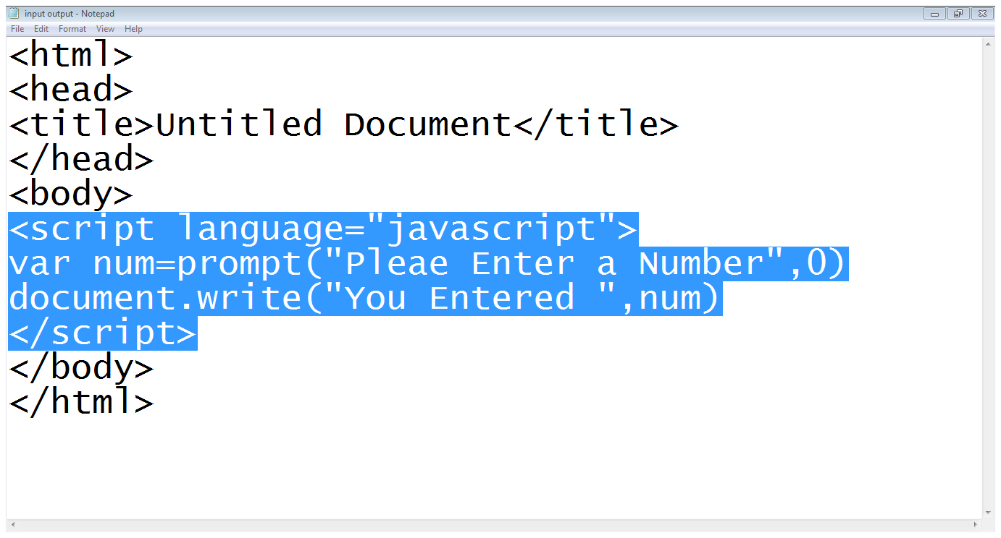

# JavaScript Functions

* User defined functions
* Predefined functions
* Functions are defined using the keyword function, followed by the name of the function and list of parameters

function *functionName*([*parameters*])

{

[*statements*]

}

* Calling a function

The syntax of a function call is:

*functionName*([*arguments*])

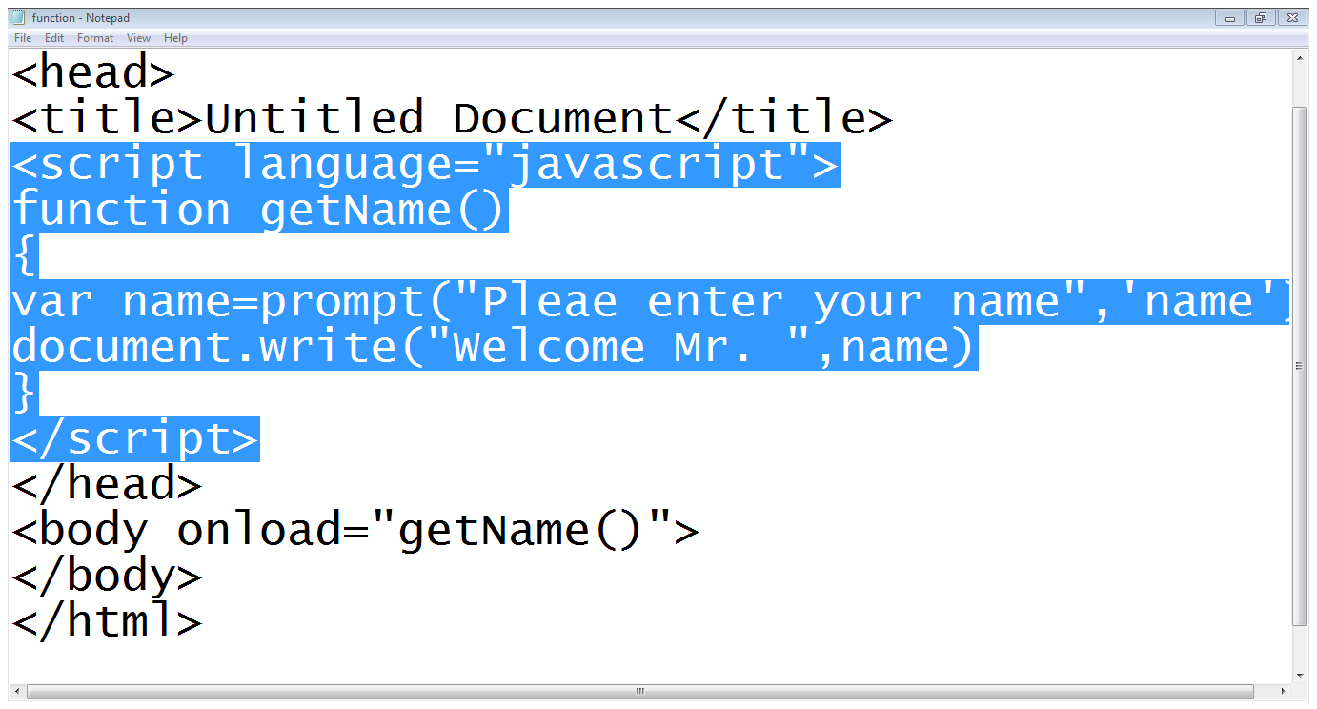

# Common events

* onClick
* onDblClick
* onChange
* onFocus
* onMouseOver
* onMouseOut
* onSubmit
* onload

Some common predefined math functions

* Math.sqrt
* Math.pow
* Math.abs
* Math.max
* Math.min
* Math.floor
* Math.ceil
* Math.round
* Math.random

# Conditional statements

* If statement

if (condition)

statement

if(condition)

{ statements }

* If-else statement

if(condition)

{statement}

else

{statements}

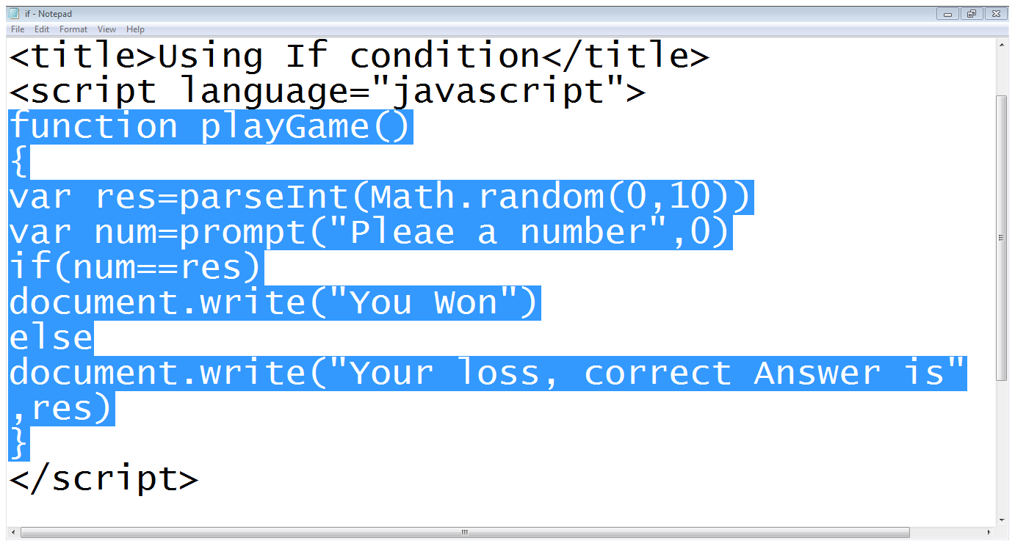

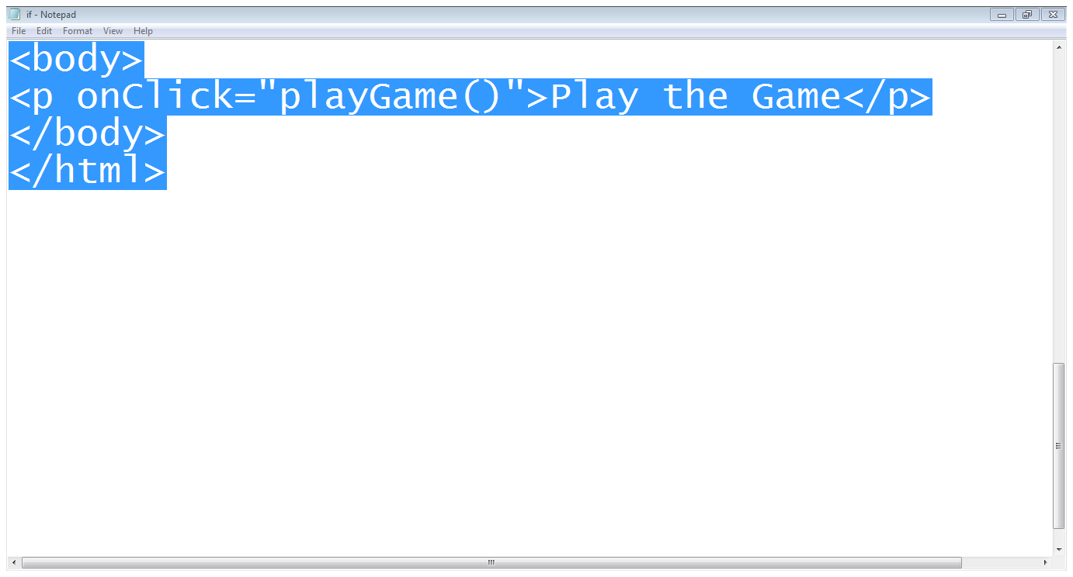

# Loops

* For loop

for(var i=1; i<10; i++)

{

Document.write(“hello world”)

}

* While loop

While(condition)

{

}

